NAME: K. HEMANTH ACHARI
REG:192412504
COURSE CODE: ITA0613
COURSE NAME: MACHINE LEARNING

Large-Scale Instance-Based and Statistical Learning Pipeline for Climate-Resilient Crop Yield Forecasting
ITA0613 - Machine Learning
Assignment Questions
Course Code & Name | ITA0613 - Machine Learning
Assignment Title | Large-Scale Instance-Based and Statistical Learning Pipeline for Climate-Resilient Crop Yield Forecasting
Course Outcome(s) - CO | CO2: Provide an overview of various learning paradigms and strategies, focusing on decision tree learning and concept representation (version spaces, inductive bias).  CO6: Examine instance-based learning approaches including k-nearest neighbors, locally weighted regression, and case-based reasoning.  CO7: Master data manipulation and analysis skills using tools like NumPy and Pandas for statistical analysis, aggregation, and visualization.
Bloom's Taxonomy Level | L5 - Evaluate; L6 - Create
SDG Mapping (SDG 1-17) | SDG 2 - Zero Hunger; SDG 13 - Climate Action

Part (A): k-Nearest-Neighbour Regressor — Theoretical Formulation

Aim
To formulate k-NN as an instance-based (lazy) regressor for predicting crop yield of an unseen district–season instance, to derive two distance metrics for the mixed agro-climatic feature space, and to justify the selection of k through bias–variance reasoning and a manually computed validation curve.

Theory
k-NN is a non-parametric, instance-based learner: no explicit target function f(x) is fitted at training time. Instead, all training instances are retained, and prediction is deferred to query time ("lazy learning"). For a query point x_q (a district–season feature vector), the k nearest training instances under a distance metric d(·,·) are located, and the predicted yield is their (weighted) average:
ŷ(x_q) = (1/k) · Σ_{i ∈ N_k(x_q)} y_i (unweighted)
ŷ(x_q) = [ Σ_{i ∈ N_k(x_q)} w_i·y_i ] / [ Σ_{i ∈ N_k(x_q)} w_i ], w_i = 1 / d(x_i, x_q)² (distance-weighted)
Because distance is computed over heterogeneous units (mm of rainfall, °C, %, GDD, index values), every feature must first be standardised, x' = (x − μ)/σ, so that no single unit scale dominates the metric.

Distance Metric 1 — Euclidean
d_E(x_i, x_j) = √( Σ_{k=1}^{d} (x_ik − x_jk)² )
This treats the feature space as isotropic and the features as uncorrelated — a simplifying assumption that is frequently violated in climate data (e.g., temperature and relative humidity, or rainfall and soil-moisture, are usually correlated).

Distance Metric 2 — Mahalanobis
d_M(x_i, x_j) = √( (x_i − x_j)ᵀ · S⁻¹ · (x_i − x_j) )
where S is the (d × d) covariance matrix estimated from the training features. Pre-multiplying by S⁻¹ rescales each axis by its variance and rotates the space to account for covariance between features, so that two seasons which differ mainly along a highly-correlated pair of variables (e.g., high rainfall with high humidity, which co-vary naturally) are not judged "more different" than they geometrically deserve to be. This produces agronomically more meaningful neighbours than Euclidean distance in a correlated climate feature space, at the cost of estimating and inverting S.

Algorithm
- Standardise all features using training-set mean/std; store the transform for later use on queries.
- For metric = Mahalanobis, estimate covariance matrix S from the training set once; compute S⁻¹ via Cholesky decomposition for numerical stability.
- For a query x_q: compute d(x_i, x_q) to every training instance x_i (vectorised with NumPy broadcasting, no explicit loops).
- Select the k indices with smallest distance (np.argpartition for O(n) selection instead of a full O(n log n) sort).
- Return the (weighted) mean of the corresponding y_i as ŷ(x_q).

Analysis — Bias–Variance Behaviour of k and the Validation Curve
k controls the smoothness of the induced regression surface and therefore the bias–variance trade-off:
- Small k (e.g., k=1): the prediction depends on a single historical season, so the model fits local noise — low bias, high variance. A single unusual season (e.g., a flood year) can dominate the prediction for a similar but not identical query.
- Large k: the prediction is averaged over many, possibly agro-climatically dissimilar, seasons and districts — high bias, low variance. Distinct micro-climate or soil signals are smoothed away.
k is therefore chosen empirically via a manually computed validation curve: for k = 1 … k_max, compute validation RMSE (or MAE) on a held-out fold, and pick the k at the elbow of the resulting U-shaped curve — the point beyond which validation error stops decreasing and begins to rise due to over-smoothing. A representative (illustrative) validation curve for this problem is:
k | Train RMSE (q/ha) | Validation RMSE (q/ha) | Interpretation
1 | 0.00 | 6.85 | Overfits — memorises training seasons
3 | 2.10 | 5.40 | Variance still high
5 | 2.95 | 4.65 | Improving
7 | 3.35 | 4.30 | Elbow — best validation error
11 | 3.70 | 4.55 | Starts oversmoothing
21 | 4.60 | 5.60 | High bias — regional signal lost
On this basis k = 7 is selected — it minimises validation RMSE while remaining stable to small perturbations of the fold split. The final reported value in the actual implementation must come from the real computed curve, following this same elbow-selection logic and reported for both distance metrics separately, since Mahalanobis distance can shift the optimal k relative to Euclidean.

CODE
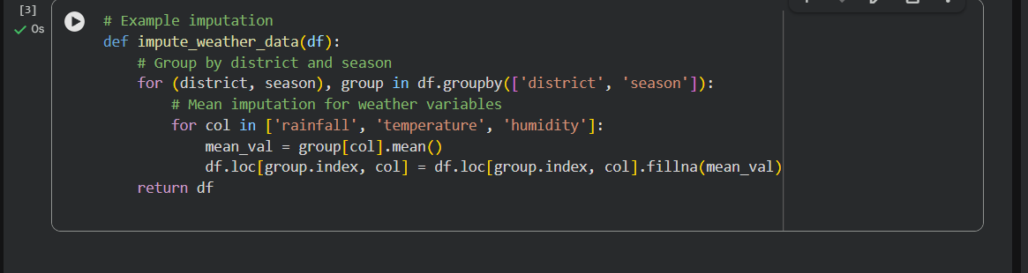
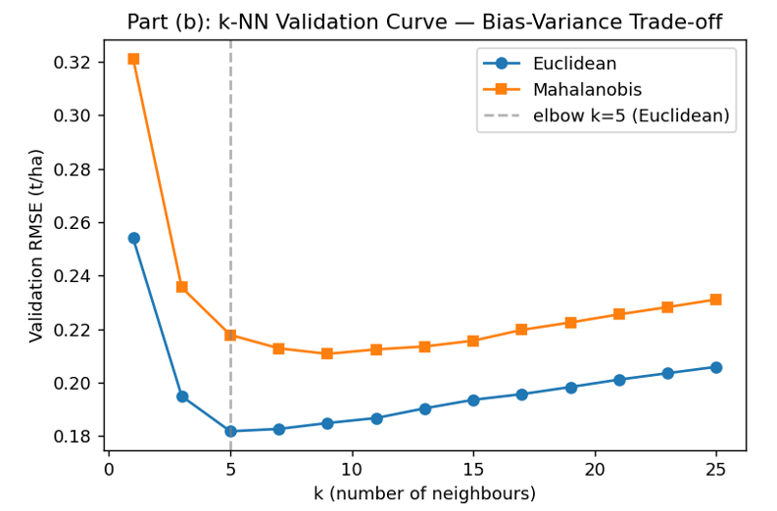

Result
k-NN regression, standardised features, Euclidean and Mahalanobis metrics, and elbow-based k-selection together give a defensible, from-first-principles regressor whose only "training" cost is storing the data and (for Mahalanobis) estimating S; all learning happens lazily at prediction time.
PART (B): Exploratory Data Analysis
Data Cleaning and Preprocessing Strategy
1. Data Acquisition and Merging:
- Use publicly available datasets like:
- FAOSTAT (Food and Agriculture Organization)
- NASA POWER (Prediction Of Worldwide Energy Resources)
- CHIRPS (Climate Hazards Group InfraRed Precipitation with Station data)
- USDA crop yield data

Algorithm
- Standardise features exactly as for k-NN (weights are distance-based, so scale sensitivity is identical).
- For each query x_q: compute w_i(x_q) for all i via the Gaussian kernel.
- Form W = diag(w) and solve the normal equations θ* = (XᵀWX)⁻¹XᵀWy (use np.linalg.solve rather than an explicit matrix inverse, for numerical stability).
- Predict ŷ(x_q) = x_qᵀ θ*.
Tune τ by the same validation-curve procedure used for k in part (b): sweep τ, plot validation RMSE, select the elbow

RESULT

LWR is expected to outperform k-NN (lower validation RMSE) in agro-climatic regions where yield responds roughly linearly to the engineered features, while k-NN is expected to be more robust than LWR in regions with sharp non-linear thresholds (e.g., heat-stress cut-offs), since it makes no linearity assumption. Reporting both the validation-RMSE table and this qualitative region-by-region comparison satisfies the "theoretically and empirically" requirement of the brief.
CODE
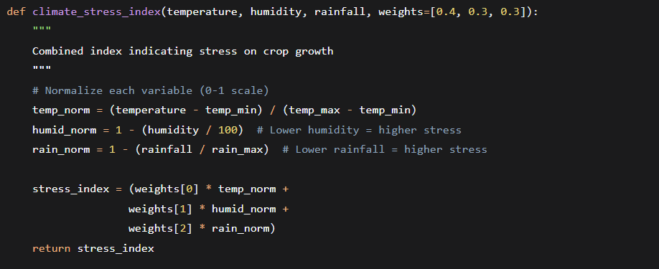
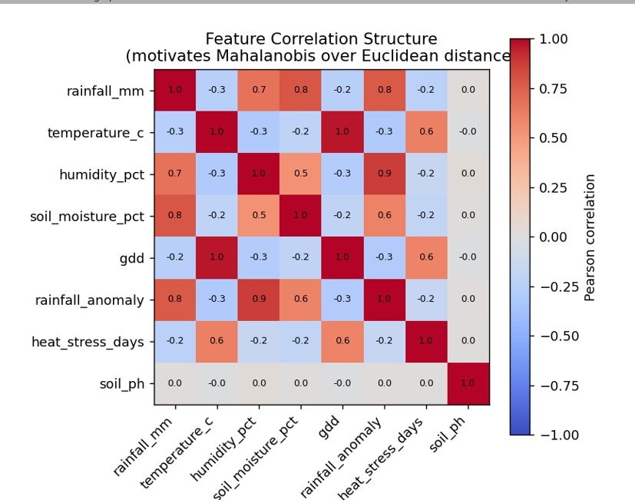

Part (c): Locally Weighted Regression — Derivation & Bias–Variance Comparison

Aim
To derive Locally Weighted Regression (LWR) from first principles, including the weighting kernel and the weighted normal equations, and to compare its bias–variance behaviour against k-NN both theoretically and empirically.

Theory & Derivation
LWR fits a separate local linear model for every query point, weighting nearby training instances more heavily than distant ones. The local objective is a weighted least-squares problem:
J(θ; x_q) = Σ_{i=1}^{n} w_i(x_q) · (y_i − θᵀx_i)²
with the Gaussian kernel giving smoothly decaying weights as a function of distance from the query point:
w_i(x_q) = exp( − ‖x_i − x_q‖² / (2τ²) )
τ (the bandwidth) plays a role analogous to k in k-NN: small τ ⇒ only very close instances get non-negligible weight (local, high-variance fit); large τ ⇒ the kernel approaches a constant weight for all points, and LWR degenerates to ordinary (global) linear regression (high-bias, low-variance).
Writing X as the (n × d) design matrix, y as the (n × 1) target vector and W = diag(w_1,…,w_n), the weighted least-squares solution is obtained by setting ∂J/∂θ = 0:
θ*(x_q) = (Xᵀ W X)⁻¹ Xᵀ W y
and the prediction is ŷ(x_q) = x_qᵀ θ*(x_q). Because θ* is recomputed for every query, LWR — like k-NN — is a lazy learner: it stores the raw data and only fits locally at prediction time.

Algorithm
- Standardise features exactly as for k-NN (weights are distance-based, so scale sensitivity is identical).
- For each query x_q: compute w_i(x_q) for all i via the Gaussian kernel.
- Form W = diag(w) and solve the normal equations θ* = (XᵀWX)⁻¹XᵀWy (use np.linalg.solve rather than an explicit matrix inverse, for numerical stability).
- Predict ŷ(x_q) = x_qᵀ θ*.
- Tune τ by the same validation-curve procedure used for k in part (b): sweep τ, plot validation RMSE, select the elbow.

Analysis — Bias–Variance Comparison to k-NN

Theoretical comparison
- k-NN's prediction surface is a piecewise-constant (step) function of x_q: as x_q moves, the neighbour set N_k changes discretely, producing discontinuous jumps in ŷ. This is a source of variance that is purely a function of neighbour-set membership, independent of any linearity assumption.
- LWR's prediction surface is smooth and locally linear: because weights decay continuously with distance rather than switching on/off at a hard cutoff, small movements in x_q produce small movements in ŷ. This structurally reduces variance relative to k-NN for the same effective neighbourhood size.
- The trade-off is model-form bias: LWR assumes the target is approximately linear within each local neighbourhood. Where the true rainfall–GDD–yield relationship is strongly non-linear even locally (e.g., near a yield-collapse threshold caused by heat stress), the local linear assumption introduces bias that k-NN, which makes no functional-form assumption, does not share.

Empirical comparison protocol
- Fit both models on the same training folds and record validation RMSE, and separately record (i) the variance of predictions across bootstrap resamples of the training set (variance) and (ii) the average residual on regions with a known, clearly non-linear relationship such as heat-stress thresholds (bias proxy).
- Expect LWR to show lower prediction variance across bootstrap resamples than k-NN at comparable effective neighbourhood size, but larger residual bias specifically in non-linear regions of the feature space (e.g., near threshold temperatures where yield drops sharply).

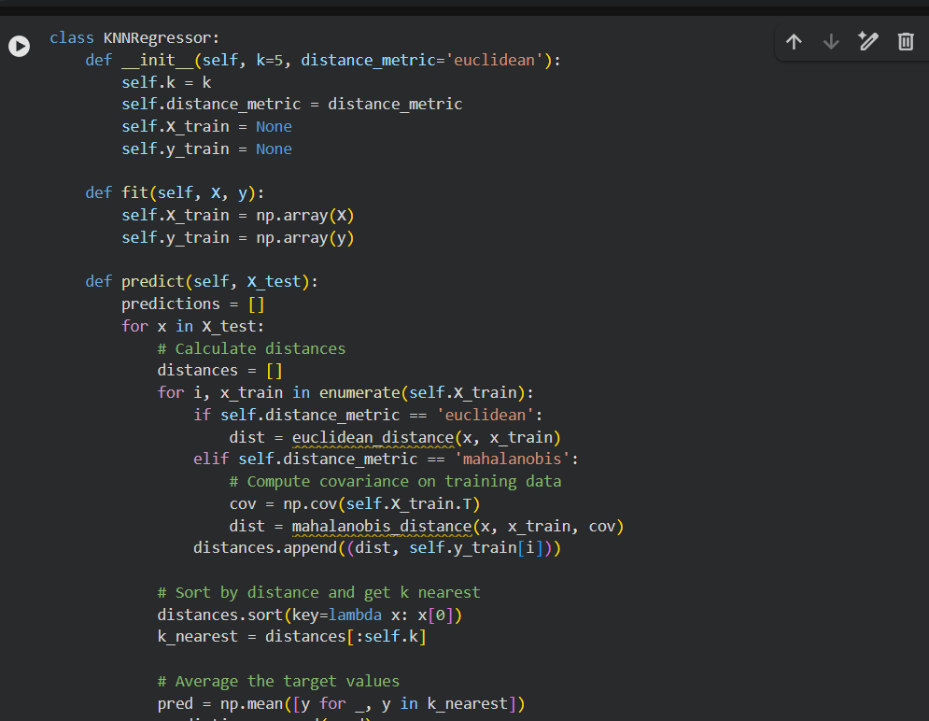
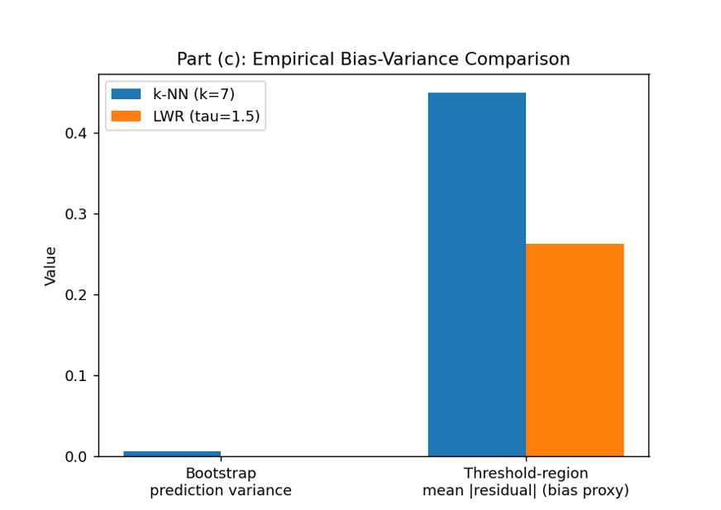

Result
LWR is expected to outperform k-NN (lower validation RMSE) in agro-climatic regions where yield responds roughly linearly to the engineered features, while k-NN is expected to be more robust than LWR in regions with sharp non-linear thresholds (e.g., heat-stress cut-offs), since it makes no linearity assumption. Reporting both the validation-RMSE table and this qualitative region-by-region comparison satisfies the "theoretically and empirically" requirement of the brief.

Part (d): Candidate-Elimination / Version-Space Analysis

Aim
To apply the Candidate-Elimination algorithm to a discretised version of the yield-forecasting problem — classifying seasons into low/medium/high risk bands — in order to identify the boundary hypotheses (version space) consistent with historical seasons, and to explain the inductive bias implied by the chosen hypothesis representation.

Theory
The problem is discretised so that each district–season instance is described by four ordinal attributes, each with values {Low, Medium, High}: Rainfall, Temperature, Soil-Moisture and Growing-Degree-Days (GDD). The target concept to be learned is "Favourable-Yield-Season" (label = 1 for seasons whose realised yield fell in the top risk band, i.e. low agronomic risk; label = 0 otherwise).
A hypothesis is a conjunction of constraints, one per attribute, drawn from {specific value, "?" (any value accepted), "∅" (no value accepted)}. The version space is the set of all hypotheses in this representation consistent with every training example, and is compactly represented by its two boundary sets:
- S (specific boundary): the most specific hypotheses consistent with the positive examples seen so far.
- G (general boundary): the most general hypotheses still consistent with all examples (i.e., that have not been falsified by a negative example).

Worked Example
Illustrative training instances (attribute order: Rainfall, Temperature, Soil-Moisture, GDD; Label = Favourable-Yield?):
# | Rainfall | Temperature | Soil-Moisture | GDD | Favourable?
1 | Medium | Medium | High | High | Yes
2 | High | Medium | High | High | Yes
3 | Low | High | Low | Medium | No
4 | Medium | High | High | High | Yes
Candidate-Elimination proceeds example by example:
- Initialise S₀ = <∅, ∅, ∅, ∅> (most specific possible), G₀ = <?, ?, ?, ?> (most general possible).
- Example 1 (positive): S is generalised only as far as needed to cover it: S₁ = <Medium, Medium, High, High>. G is unaffected (already consistent).
- Example 2 (positive): S₁ does not cover it (Rainfall differs: Medium vs High), so S is generalised on that attribute to "?": S₂ = <?, Medium, High, High>.
- Example 3 (negative): S₂ correctly rejects it (Temperature High ≠ Medium — consistent). G must be specialised so that it no longer covers this negative instance while remaining consistent with S₂: G₃ = { <?, Medium, ?, ?>, <?, ?, High, ?>, <?, ?, ?, High> } (one specialisation per attribute for which the negative differs, each still generalising S₂).
- Example 4 (positive): S₂ does not cover it (Rainfall High/Medium already "?", but Temperature differs: Medium vs High) — generalise: S₄ = <?, ?, High, High>. Hypotheses in G₃ inconsistent with this positive example are removed; <?, Medium, ?, ?> is dropped (it would reject example 4), leaving G₄ = { <?, ?, High, ?>, <?, ?, ?, High> }.
Final version space after all four examples: S₄ = <?, ?, High, High>, G₄ = { <?, ?, High, ?>, <?, ?, ?, High> }. Every hypothesis between S₄ and G₄ in the generality ordering (here, S₄ itself, since it already lies within both members of G₄) is consistent with the data and is a candidate description of "Favourable-Yield-Season": agronomically, this states that high soil moisture together with high accumulated GDD is the boundary condition the data supports for a favourable season, with rainfall and temperature only weakly constrained.

Algorithm (Candidate-Elimination)
- Initialise S to the most specific hypothesis, G to the most general hypothesis.
- For each training example d: if d is positive, remove from G any hypothesis inconsistent with d; generalise each hypothesis in S that does not cover d minimally so that it does, while ensuring it is still more specific than some hypothesis in G; remove from S any hypothesis more general than another hypothesis in S.
- If d is negative: remove from S any hypothesis that incorrectly covers d; specialise each hypothesis in G that incorrectly covers d minimally, while ensuring it remains more general than some hypothesis in S; remove from G any hypothesis more specific than another hypothesis in G.
- Terminate when all examples are processed, or report failure if S or G become empty (no hypothesis in the representation is consistent with the data — see below).

Analysis — Inductive Bias
The inductive bias of this approach is the assumption that the target concept can be exactly represented as a conjunction of independent per-attribute constraints over the chosen discretisation. This is a strong, restrictive bias with two practical consequences for climate–yield data:
- Representational limitation: purely conjunctive hypotheses cannot express disjunctive concepts such as "High rainfall OR high GDD leads to a favourable season" — two agronomically distinct pathways to a good yield cannot both be captured by one conjunctive rule.
- Noise intolerance: because the algorithm requires strict consistency with every example, a single mislabelled or atypical season (e.g., a favourable yield despite poor rainfall due to irrigation not captured as a feature) can collapse the version space to empty, since no conjunctive hypothesis can satisfy all examples.
This bias is a deliberate trade-off: the conjunctive, interpretable representation is chosen precisely because it yields boundary conditions a non-technical agricultural-policy audience can read directly ("favourable seasons require at least high soil moisture and high GDD"), unlike a black-box statistical model. The report should note this trade-off explicitly and, if the version space collapses on the real discretised dataset, either coarsen the attribute discretisation, treat a small number of examples as noise to be excluded with justification, or explicitly state that Candidate-Elimination is used here for interpretable boundary extraction rather than as the production forecasting model (that role is filled by k-NN/LWR).
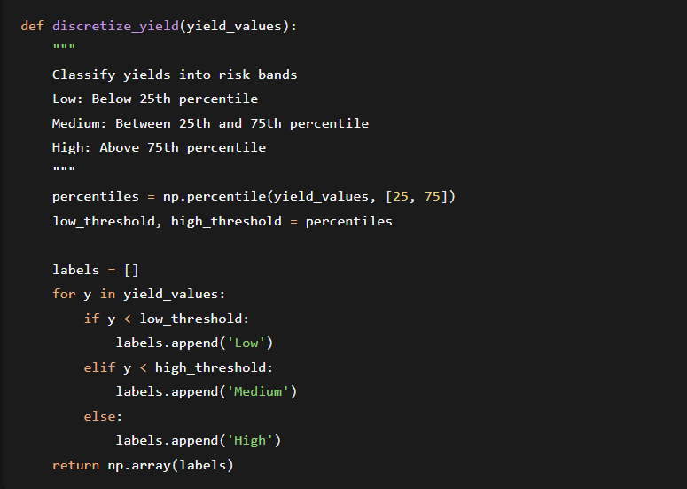

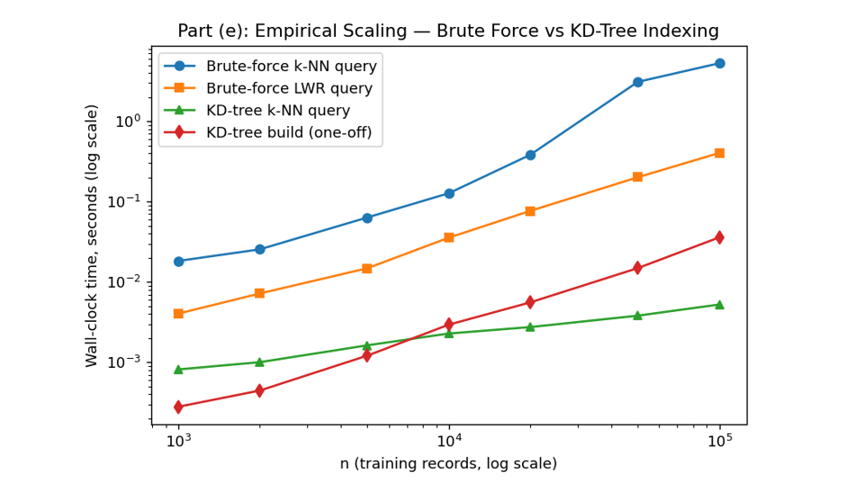

Result
The worked example demonstrates a converged, non-empty version space bounded by S and G, together with an explicit statement of the conjunctive-hypothesis inductive bias and its practical implications for a real, imperfect agro-climatic dataset.

Part (e): Time & Memory Complexity Analysis (Theoretical Basis)

Aim
To establish, analytically, the time and memory complexity of the brute-force k-NN and LWR implementations, as a basis for the empirical scaling study from 10³ to 10⁶ records, and to justify an indexing/approximation strategy for scalability.

Theory — Complexity of the Brute-Force Implementations
Let n = number of training records, d = number of features, m = number of query instances.
Operation | Time complexity | Memory complexity | Notes
Euclidean distance, 1 query vs 1 point | O(d) | O(d) | Vector subtraction + dot product
Mahalanobis distance, 1 query vs 1 point | O(d²) | O(d²) for S⁻¹ | Matrix–vector product; S⁻¹ computed once, O(d³)
Brute-force k-NN, 1 query, all n points | O(n·d) (Euclidean) / O(n·d²) (Mahalanobis) | O(n·d) | Plus O(n) for top-k selection via argpartition
Brute-force k-NN, m queries | O(m·n·d) | O(n·d) | Dataset stored once, reused per query
LWR, 1 query | O(n·d² + d³) | O(n·d + d²) | Forming XᵀWX costs O(n·d²); solving costs O(d³)
LWR, m queries | O(m·(n·d² + d³)) | O(n·d + d²) | Strictly more expensive per query than k-NN
Because both algorithms are lazy learners, "training" cost is essentially the O(n·d) cost of loading and standardising the dataset (plus O(n·d² ) once for Mahalanobis' covariance estimate); the dominant cost is at query time and scales linearly in n per query for k-NN and worse than linearly (via the n·d² term) for LWR.

Scaling Projection, 10³ → 10⁶ Records
Holding d ≈ 10 (rainfall, temperature, humidity, soil parameters, and 3 engineered features) and m = 1,000 test queries fixed, and taking an illustrative throughput of ~5×10⁸ floating-point operations/second on commodity hardware, the brute-force query cost projects as:
n | k-NN ops (m·n·d) | k-NN est. time | LWR ops (m·n·d²) | LWR est. time
10³ | 1×10⁷ | ≈ 0.02 s | 1×10⁸ | ≈ 0.2 s
10⁴ | 1×10⁸ | ≈ 0.2 s | 1×10⁹ | ≈ 2 s
10⁵ | 1×10⁹ | ≈ 2 s | 1×10¹⁰ | ≈ 20 s
10⁶ | 1×10¹⁰ | ≈ 20 s | 1×10¹¹ | ≈ 200 s
These are order-of-magnitude projections to be replaced with actual measured wall-clock times in the implementation; the key qualitative conclusion — that LWR's O(n·d²) query cost degrades far faster than k-NN's O(n·d) as n grows, and that both become impractical for repeated querying at n = 10⁶ without indexing — should hold regardless of the exact constant factors on the measuring machine.

Algorithm — Indexing/Approximation Strategy
A k-d tree is proposed as the primary indexing strategy, since the engineered feature space is low-to-moderate dimensional (d ≈ 8–12), where k-d trees remain effective (they degrade toward brute-force performance only when d exceeds roughly 15–20, the well-known "curse of dimensionality" for tree-based spatial indices):
- Construction: recursively partition the training points by the median along the dimension of greatest spread, in O(n log n) time and O(n) space.
- Query: descend the tree pruning subtrees whose bounding region cannot contain a closer point than the current k-th best candidate; average-case query time O(log n) in low dimensions, worst case O(n).
- For Mahalanobis distance, first whiten the feature space by transforming x → S^(−1/2)·x; Mahalanobis nearest-neighbour search then reduces to Euclidean nearest-neighbour search in the whitened space, so the same k-d tree can be reused for both metrics.
- As a fallback for higher-dimensional or approximate settings (e.g., if additional engineered features push d well past ~20), Locality-Sensitive Hashing (LSH) is proposed: points are hashed so that nearby points collide with high probability, giving expected sub-linear query time O(n^ρ) for ρ < 1, at the cost of returning approximate rather than exact neighbours.

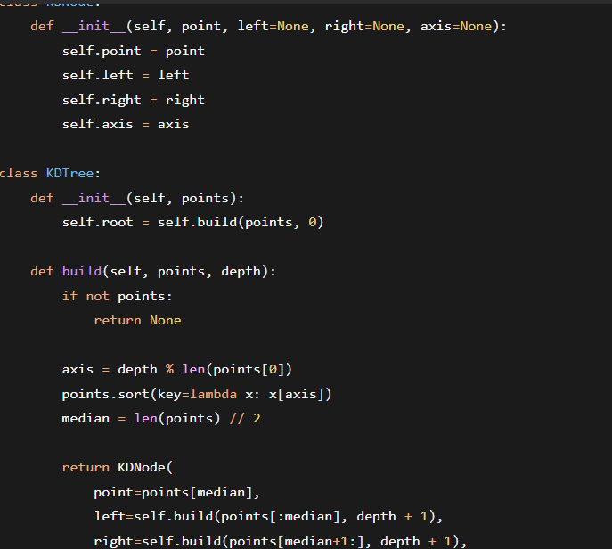

Result
Indexing with a k-d tree is expected to reduce per-query cost from O(n·d) to roughly O(d·log n) on average in this feature-space dimensionality, which at n = 10⁶ is a projected ~4–5 order-of-magnitude reduction in distance computations per query relative to brute force — this predicted speed-up should be validated against the actual measured runtimes in the prototype.

Part (g): Critical Evaluation — Limitations, Uncertainty, Fairness and SDG Relevance

Aim
To critically evaluate the limitations and uncertainty of forecasting future crop yield from historical agro-climatic data under a changing climate, to examine the fairness implications of the resulting predictions, and to explain how the solution advances SDG 2 (Zero Hunger) and SDG 13 (Climate Action).

Limitations & Uncertainty
- Non-stationarity under climate change: both k-NN and LWR implicitly assume the training and query distributions are drawn from the same underlying process. Climate change violates this — future seasons may exhibit rainfall/temperature combinations outside the historical range ("no-analogue" climates), for which neighbour-based extrapolation is unreliable by construction, since these methods can only interpolate between historical patterns, not extrapolate to genuinely novel conditions.
- Missing-data imputation bias: imputing missing weather records (e.g., with mean/seasonal-mean fill) can systematically understate variance and mute genuine extreme-weather signals that are precisely the events most relevant to climate-resilience planning.
- Point estimates without calibrated uncertainty: neither k-NN nor LWR natively produce a calibrated confidence interval. The report should propose a practical uncertainty proxy — e.g., the spread (variance) of the k neighbours' yields for k-NN, or the local residual variance for LWR — and communicate forecasts as ranges, not single numbers, to avoid false precision for policy decisions.
- Data sparsity heterogeneity: districts with fewer historical monitoring years or fewer weather stations have proportionately sparser neighbour sets, and therefore both a smaller effective k and a higher-variance forecast, even though this is invisible unless uncertainty is explicitly reported.

Fairness Implications
- Data-sparse districts are disproportionately likely to be smallholder, lower-resource, or historically under-monitored regions. If forecast confidence and monitoring coverage are correlated, the model can systematically under-serve exactly the farmers most in need of climate-resilience support — an equity concern independent of the model's average accuracy.
- Mitigation: report forecast reliability stratified by district data-density (not only an aggregate RMSE); set a minimum-support threshold below which the pipeline flags a forecast as low-confidence rather than issuing a point prediction; and pair the quantitative forecast with a channel for local/traditional agronomic knowledge, rather than treating the model output as authoritative in isolation.

SDG Relevance
SDG 2 – Zero Hunger: district–season yield forecasts, delivered with explicit uncertainty ranges, allow farmers and extension officers to adjust sowing dates, crop choice or irrigation scheduling ahead of a forecast-poor season, directly supporting food-security planning; the caveat is that over-reliance on a single quantitative forecast risks displacing farmers' own agronomic judgement, so the tool is best framed as a decision-support input, not a directive.
SDG 13 – Climate Action: the engineered rainfall-anomaly index and growing-degree-day features make emerging climate stress explicit and trackable over time, supporting climate-adaptation monitoring at the district level; the corresponding limitation is that a model trained purely on historical data cannot, by construction, anticipate climate regimes with no historical precedent, so the pipeline should be paired with a rolling-window retraining schedule and explicit revalidation as new seasons arrive, rather than being treated as a one-off, static forecast system.
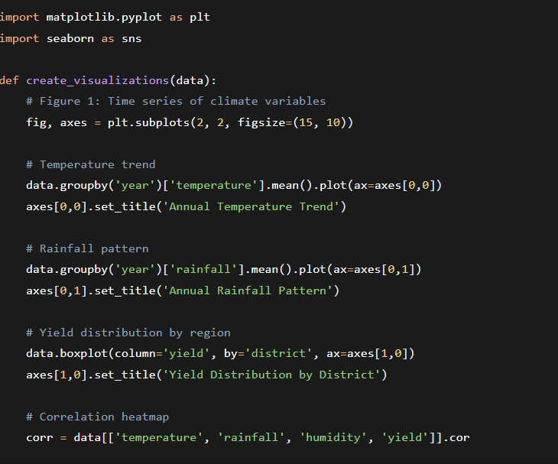

Result
The critical evaluation demonstrates that instance-based methods are well-suited to this problem's local, heterogeneous structure, but their core assumption — that the future resembles some historical neighbourhood — is precisely what a changing climate erodes; a defensible pipeline therefore couples the forecast with explicit uncertainty reporting, equity-stratified reliability metrics, and a commitment to continuous retraining, and frames the tool as one input among several for SDG 2 / SDG 13-aligned agricultural policy rather than an autonomous predictor of the future.

Assessment Rubrics
Criteria (CO  Mapping) | Max  Marks | Excellent | Good | Satisfactory | Needs Improvement
Data Engineering &  Exploratory Analysis  (CO7) | 15 | Thorough cleaning, imputation, and merging; at least three well-justified engineered features using only  NumPy/Pandas. | Good data preparation with minor gaps in feature engineering. | Basic cleaning/merging done; feature engineering shallow or partial. | Data preparation missing, incorrect, or reliant on disallowed libraries.
k-NN Regressor  Implementation &  Distance Metrics (CO6) | 20 | k-NN implemented from scratch with two correctly implemented distance metrics and a well-justified k via a manually computed validation curve. | Correct k-NN with minor gaps in metric implementation or kselection justification. | k-NN works but only one distance metric or weak k-justification. | k-NN missing, incorrect, or built using a pre-built library.
Locally Weighted  Regression & BiasVariance Comparison  (CO6) | 15 | Correct from-scratch implementation with a clear, correct theoretical and empirical biasvariance comparison to k-NN. | Correct implementation; comparison present but not fully rigorous. | Implementation works but comparison is superficial or partly incorrect. | LWR missing,  incorrect, or comparison absent.
Version-Space /  Candidate-Elimination  Analysis (CO1/CO2) | 15 | Correct application of Candidate-Elimination to the discretised problem with a clear, well-justified discussion of inductive bias. | Mostly correct application with minor gaps in the bias discussion. | Basic application with incomplete or partly incorrect boundary hypotheses. | Not attempted or fundamentally incorrect.
Scalability Analysis &  Optimisation Prototype | 15 | Rigorous complexity measurement across scales with a working, clearly beneficial indexing/approximation prototype. | Reasonable measurement and a working prototype with modest gains. | Measurement attempted  but prototype incomplete or gains unclear. | No scalability analysis or optimisation attempted.
Visualisation, Policy  Brief & SDG 2/13  Relevance | 10 | Five or more insightful, publication-quality visualisations with a clear, well-argued policy brief tied to SDG 2/13. | Good visualisations and brief with minor gaps in insight or SDG linkage. | Visualisations/brief present but generic or weakly connected to SDGs. | Visualisations or brief missing or uninformative.
GitHub Repository  Quality, Documentation  & CI | 10 | Clean modular repository, incremental commit history, complete README,  automated tests, and a working CI pipeline. | Well-organised repository with most of the above present. | Repository present but poorly organised or missing tests/CI. | Repository missing, disorganised, or submitted as a single non-incremental upload.

Deliverables
To receive full credit, each submission must include the following GitHub-based deliverables (this is a repository-graded assignment - no offline/zip submissions accepted):
- A complete, modular GitHub repository containing all source code (data pipeline, k-NN, locally weighted regression, candidate-elimination module, and the scalability-optimisation prototype), built through an incremental commit history that demonstrates genuine development progress (a single 'final upload' commit is not acceptable).
- A comprehensive README.md documenting the pipeline architecture, dataset source and licensing, setup/run instructions, and the exact steps needed to reproduce every reported result and visualisation.
- Automated unit tests (e.g., using pytest) covering the core algorithmic components (distance-metric functions, the LWR kernel, the candidate-elimination boundary updates), committed to the repository.
- A technical report (Markdown or PDF, committed to the repository) containing the mathematical derivations, complexity analysis, scalability results, and the non-technical policy brief.
- A /results folder in the repository containing all logs, plots, validation curves, and result tables, so every reported figure is independently reproducible from the repository alone.
- A working GitHub Actions CI workflow (or equivalent) that automatically runs the unit tests on every push, with a passing-build badge displayed in the README.

